

Lab 2.1.3: Working with Tableau

Tableau Public is a free-to-use Business Intelligence Data Visualisation tool commonly used in industry. The purpose of this lab is to familiarise yourself with the tool including developing the ability to create interactive charts of numerous types and combine them to form a dashboard. Many of the skills acquired here are transferable to other visualisation platforms such as PowerBI and Qlik Sense.

By the end of the lab you will have a dashboard looking like the following:
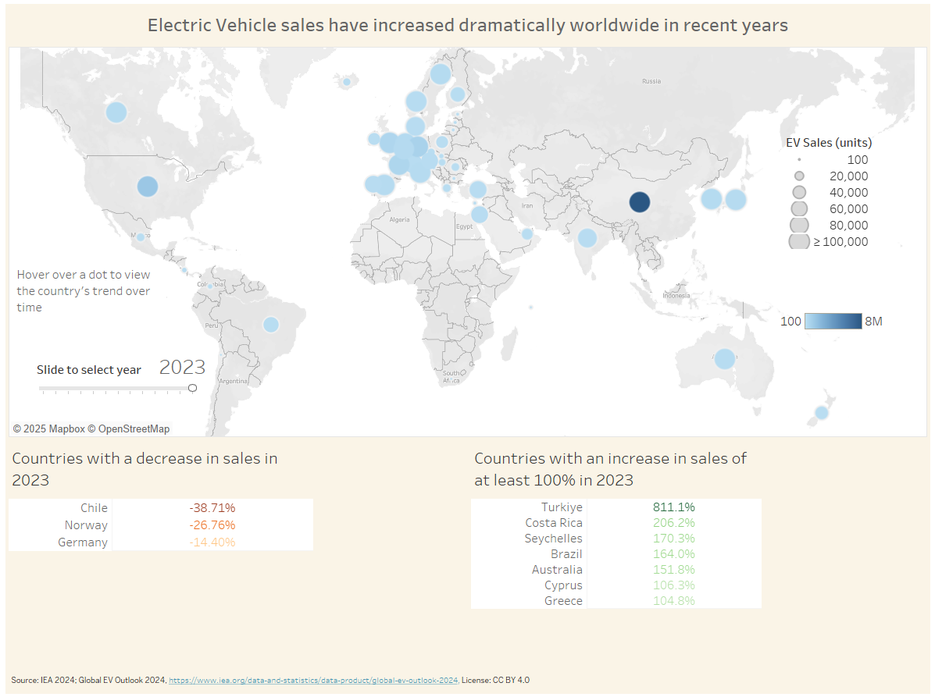

Instructions:

A. Installing and Connecting to the data source
- Download and install on your machine Tableau Public from https://www.tableau.com/products/public/download . You will need to provide your email address and you can set “-Role-” to “Personal User” or “Student”.

- Download from the DATA folder to your machine the file “IEA Global EV Data 2024.csv”. This includes both past data and future projections of electric vehicles sales worldwide.

- Upon opening Tableau Public you will see a menu on the left similar to the following. Since we will connect to a csv file, select “Text file” and then navigate to the “IEA Global EV Data 2024.csv” file on your machine (possibly in your Downloads folder).
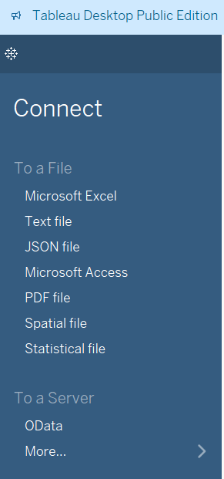
- You will see a preview of the dataset similar to the following. In this Data Source view, there is an opportunity to undertake some preliminary data transformations such as merging multiple datasets, pivoting the data or renaming columns. We will not require this here, so we may proceed to Sheet 1 by clicking on the orange tab seen in the bottom left
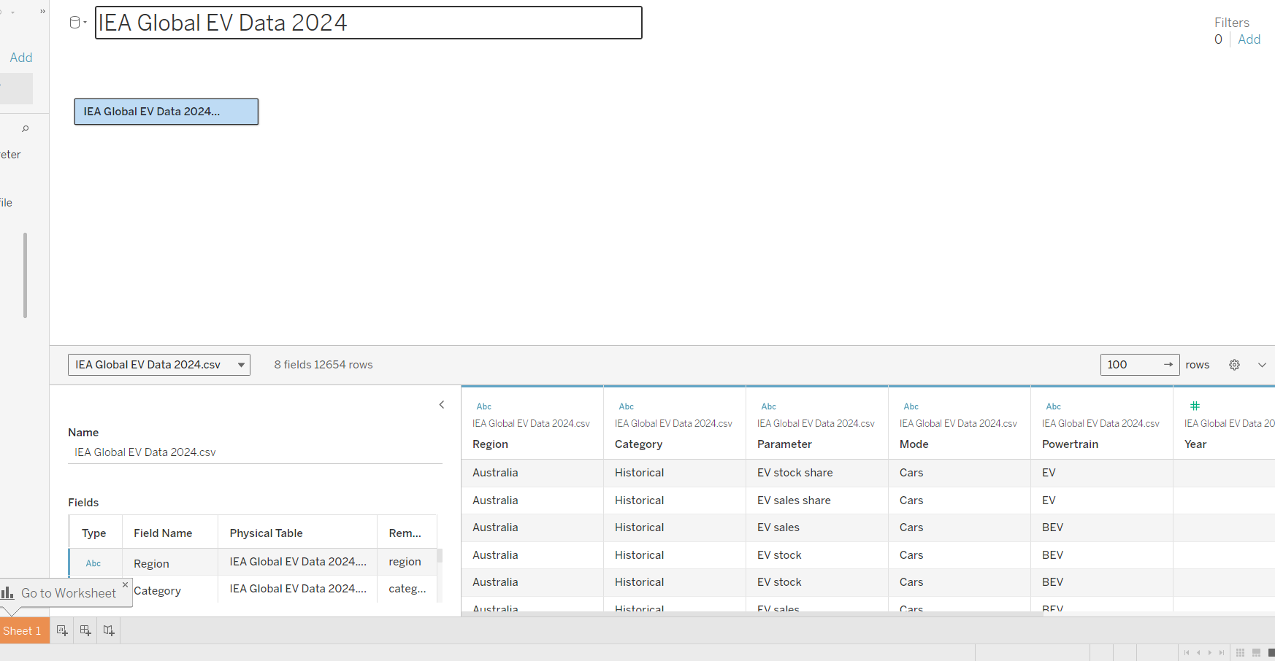

B. Chart 1 - map
In this section you will create a map showing EV sales by year. Below is the final product.

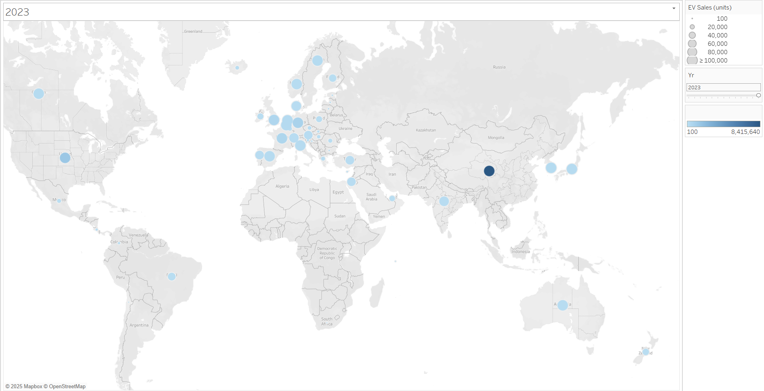

B.1 – Load in the map
We need to make Tableau recognise that the “Region” contains countries. To do this left-click on the “Abc” of the “Region” field and select “Geographic Role” -> “Country/Region”. Then a globe icon will appear indicating that Region is now of Geospatial type.

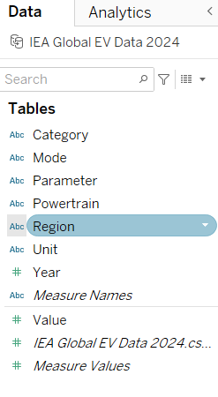

Left-click here and change to “Geographic Role” -> “Country/Region”
Drag the Region field onto the canvas (largest white area) to generate a map.
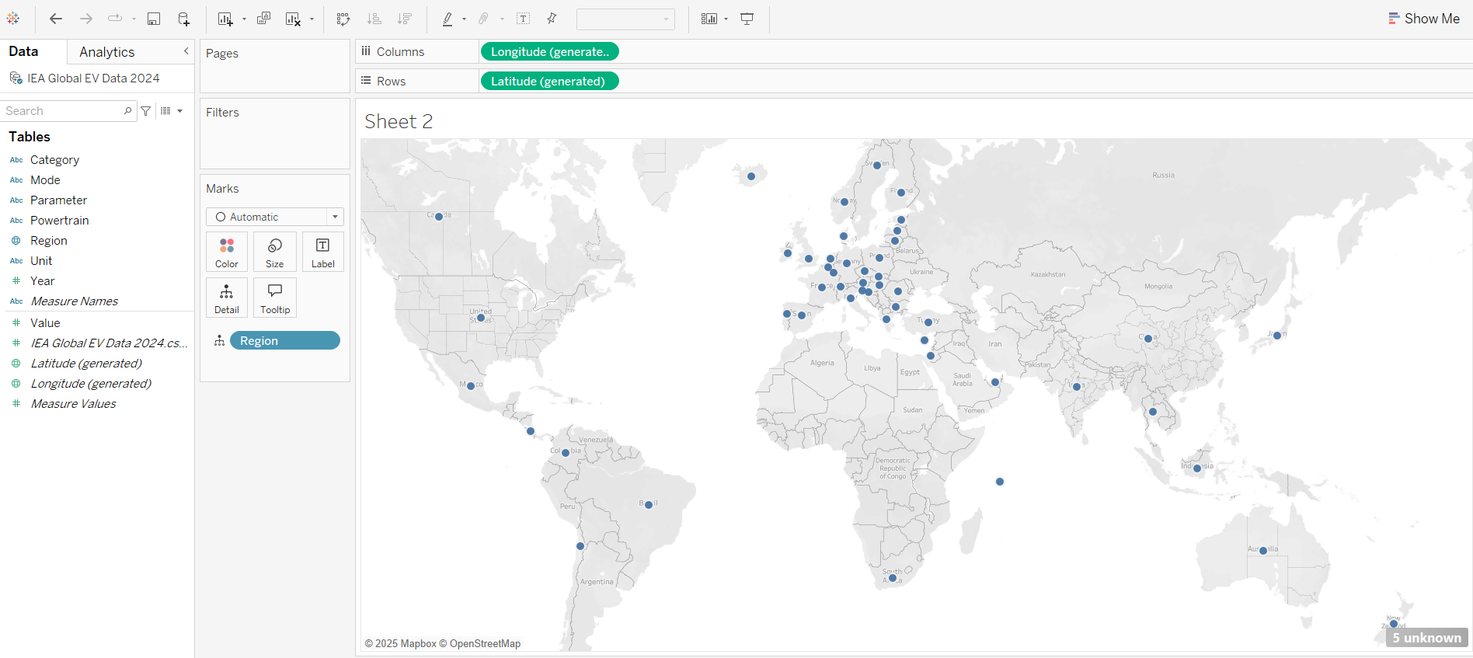

Drag “Region” onto this space to generate the map
One point to mention is that green pills (e.g. Latitude) indicate continuous data while blue pills (e.g. Region) indicate discrete data.

B.2 – Treat missing values
Note that 5 unknown values appear. Clicking there opens a box where you can select “Edit locations”. Make “Korea” match with “South Korea” under the Matching Location column and then click OK.

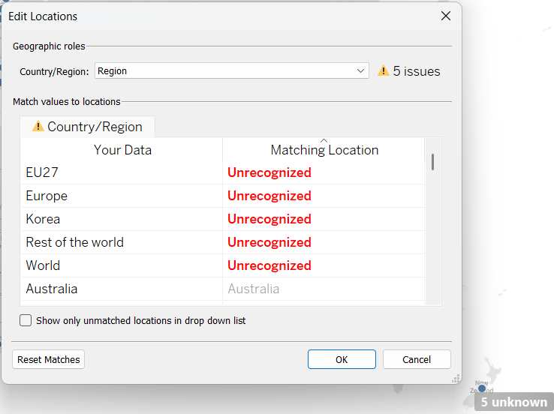

Click here, then select “Edit Locations” to reveal this box.

B.3 – Create parameters to be used in further visualisations

Click on the small arrow to the right of the left search bar and select “Create parameter…”. Call the parameter “Yr” and set current value to 2023, Data type to integer and minimum-maximum values (Allowable values as “Range”) as shown below. Also the display format can be changed by setting it to Number (Custom), show 0 decimal places and then deselecting the box titled “Include thousands separators”. Click OK at the bottom when done.

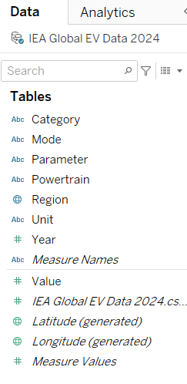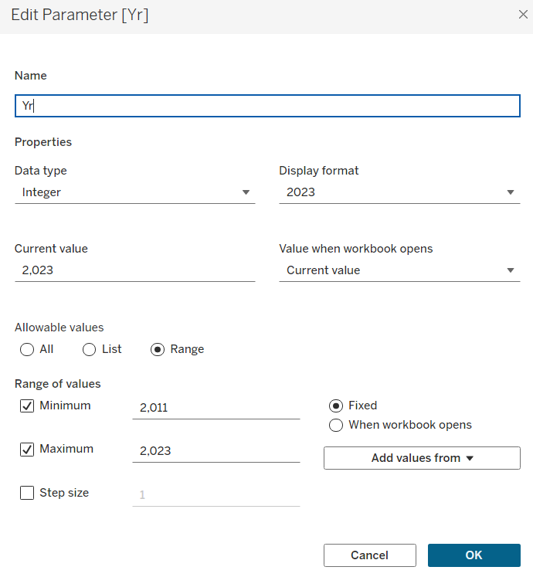

Left-click here and select “Edit Parameter…” to bring up the box seen on the right

We are going to set up a title that is the year we have selected – this will be used later in the final dashboard. To do this firstly create a new calculated field called “Chosen Year”. Enter the formula “if [Year] = [Yr] then TRUE else FALSE end” as shown below. Then click OK.
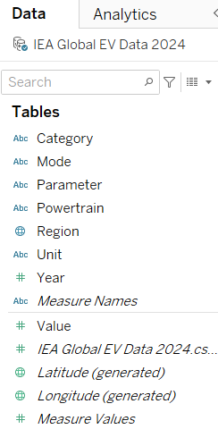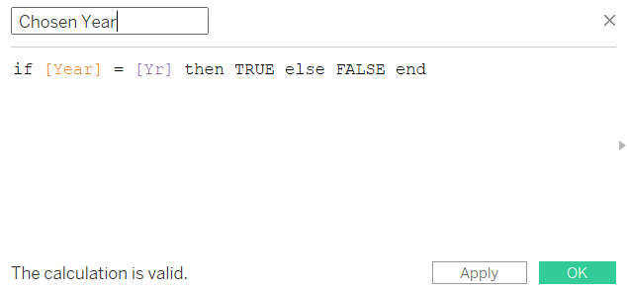

Left-click here and select “Create Calculated Field…” to open the box shown below.

This creates a Boolean variable which when TRUE enables us to select a year as a heading. It will be used as a filter later on.

B.4 – Change the sheet title
To change the title, double-click on the sheet title and then replace <Sheet.Name> with <Parameter.Yr> obtained from the Insert menu as shown below. This will ensure that the sheet title will change according to the year that we choose in the slider year filter.

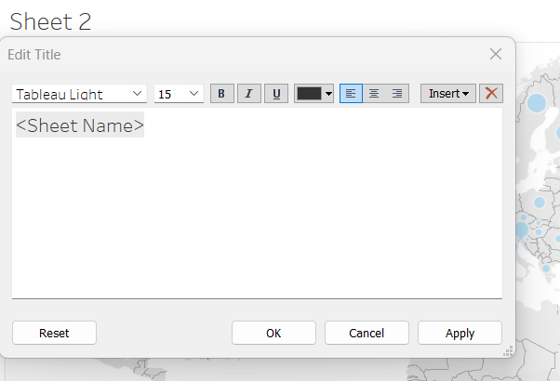

Double-click on the sheet title and then replace <Sheet Name> with <Parameter.Yr> obtained via the Insert menu

B.5 – Add a slider for Yr
Right-click on the Yr parameter on the left and choose “Show parameter”. A box like the following will appear. Then left-click at the top right of the box and select “slider”.
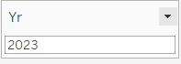

Left-click here and select “slider”

B.6 – Create filters for given specifications
Apply filters as seen in the image below. This is done by dragging and dropping the relevant fields onto the Filters card.

Region: deselect EU27, Europe, Rest of the world, World
Parameter: Select EV sales only. Change the shown filter to a Single Value (dropdown) list in a similar manner to the bar chart of the previous section.
Category: Select Historical only. Change the shown filter to a Single Value (dropdown) list.
Chosen Year: set to True

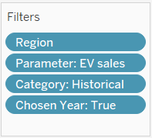

Drag Value column onto “Size”, drag value column onto “Color”. (This step should add two more legend sections in the top right corner.)
From the Sizes legend in the top right, select “Edit sizes…” and as shown below edit to have a maximum value of 100000. Also select “Edit title…” to show “EV Sales (units)”. The legend of the title of the colour bar can be made blank.

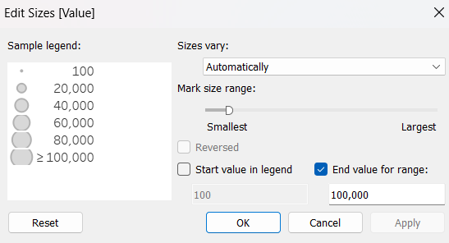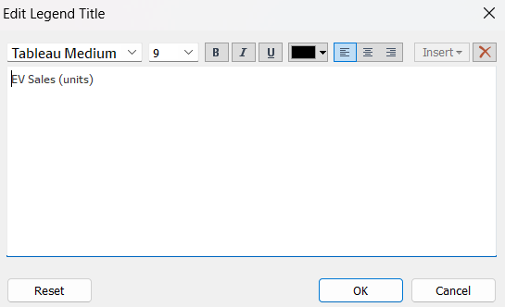

By now the chart should look similar to this. As the year is changed via the slider the title should change.


Feel free to change the colours by selecting Color, then Edit Colors…, then choose a different palette as shown below.
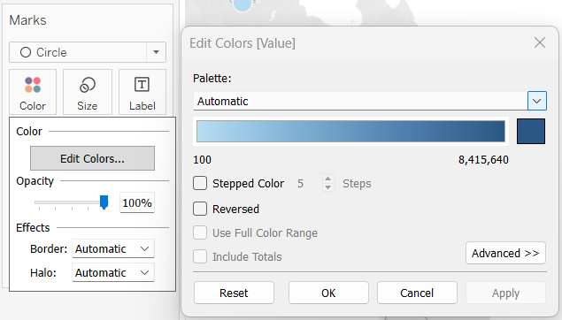

Click on “Color”, then “Edit Colors…”, then choose from other palette options.

B.7 – Change the sheet name
Double click on “Sheet 1”at the bottom left to change its name to “map”.
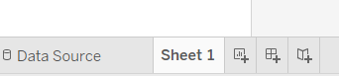

Congratulations on creating this first chart in Tableau! You can save this visualisation to your machine (File -> Save) or make it publicly available on public.tableau.com (File -> Save to Tableau Public).

C. Chart 2 - line graphs

Within the map we will include further interactivity - by showing a line graph when one hovers over one of the dots.

- Left-click on the + symbol next to your chart name at the bottom (New Worksheet) to initialise a new chart.
- Drag year up to the column shelf and Value up to the row shelf. A line graph should appear.
- Drag the field “Region” onto the graph. Now one line for each region should appear.
- Apply the following filters by firstly dragging the fields onto the Filters card.
Parameter: EV sales
Category: Historical
- Double click on “Sheet 2” at the bottom left and rename it to “line graphs”.
The view now should be as follows:

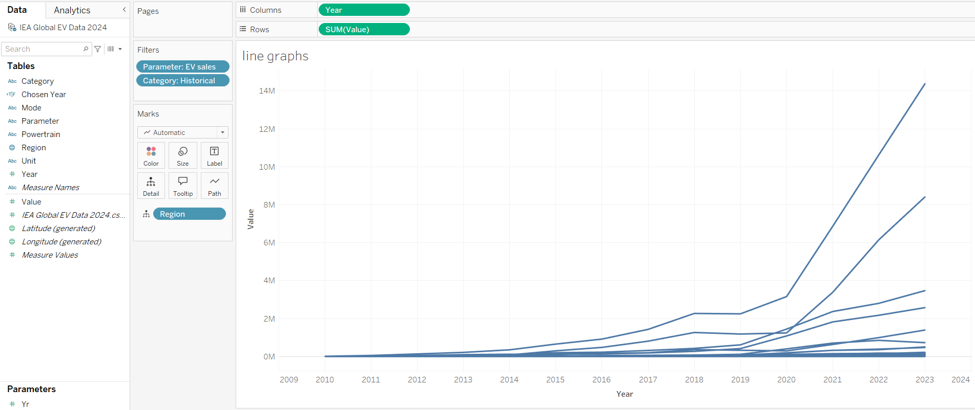

Go back to the previous “map” sheet and click on the “Tooltip” button. Change “Value” to “Sales in” and insert “line graphs” as shown below.
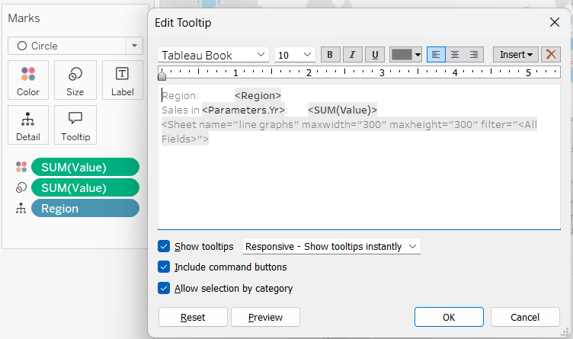

Left-click “Tooltip”, change Value to “Sales in” and use the Insert menu to include “<Parameters.Yr>” and the Sheet “line graphs”

After clicking “OK” and hovering your mouse over a country’s dot, you should see a line graph of EV sales by year corresponding to that country!

Save your work before moving on.

D. Chart 3 - showing countries with a decrease in sales
In this section we will be creating a new worksheet which shows the countries with a decrease in their EV sales. The resulting visualisation is shown below.

Start a new worksheet by clicking on the button next to the latest line graphs tab.
Rename the sheet to “Countries with a decrease in sales”
Drag Year to the Columns shelf and Region to the Rows shelf.

Apply the same filters as last time on the Filters card:
Parameter: EV sales
Category: Historical
Region: All but EU27, Europe, Rest of the world, World

Create a new Calculated Field called “Year Filter” and enter the formula “[Year] = [Yr]-1 or [Year] = [Yr]” as shown below. Dragging this field onto the Filters card and enabling it to True will then only show information for two consecutive years.

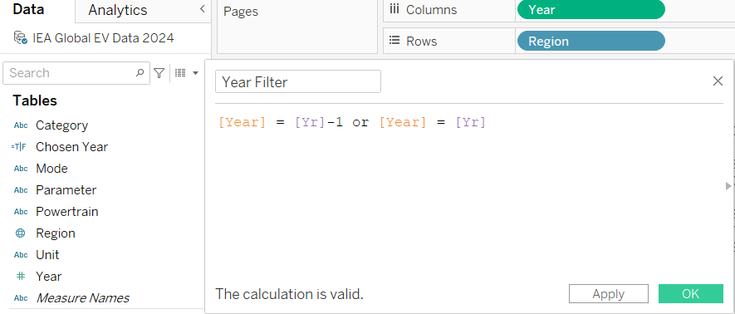

Select “Create Calculated Field…” here to open this calculation box.

Drag the “Value” column from the left onto the Text box of the Marks card. Then after left-clicking on the right side of the green pill, select “Quick Table Calculation” -> “Percent Difference”. A triangle will appear on the right side of the green pill to indicate a table calculation has been made.
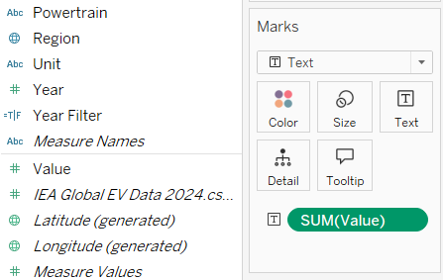

Drag “Value” onto the Text square, then after left-clicking on the right of the green pill select Quick Table Calculation -> Percent Difference

Drag the “Value” field again, this time up to the Filters card (select SUM when asked how you want to filter on [Value]) and click Next and OK.

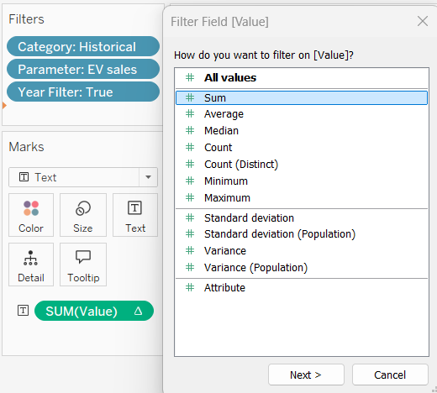
Set this green pill in the Filters card to the Percent Difference calculation. Then set the maximum value to -0.0001 as seen below.
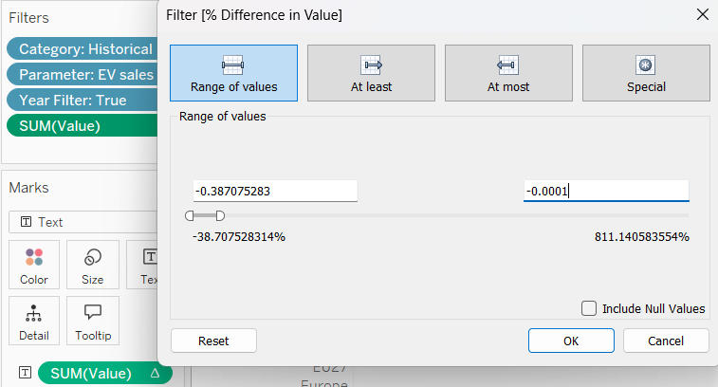
After clicking OK you should see that only a few countries are selected.

Double click on the title and edit by typing “in <Parameters.Yr>” (use the insert menu). Click OK when done.
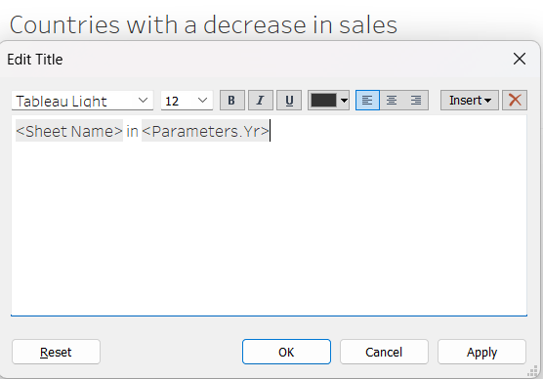

Double-click on the title and then edit the title as shown

Drag “Value” onto the Color square and set the new pill to a Percent Difference calculation as before. The numbers will appear in different colours (you may need to set Marks to “Text” from the default “Automatic” setting). These can be sorted in ascending order as seen below. The visualisation can be resized by clicking and dragging from the right.

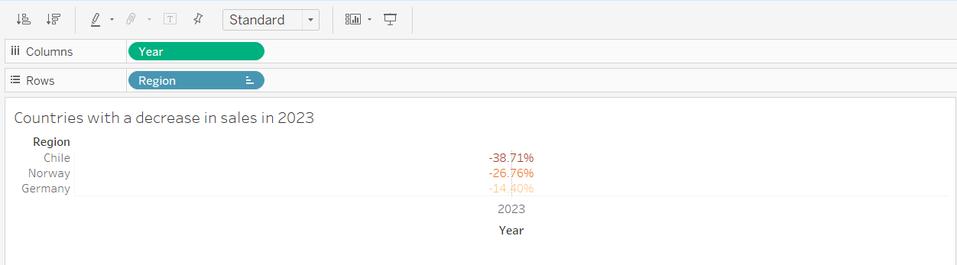

Click here to sort the values in ascending order, then drag from the right to resize
The 2023 and Year displays under the percentages can be removed by right clicking on it and deselecting the “Show Header” option. You may have to resize the rows to see the numbers and percentages in full.

E. Chart 4 - showing countries with a significant increase in sales

This chart will show countries with an increase in sales. Simply right-click on the Worksheet tab created in the previous section, select “Duplicate”, and edit the duplicated version by modifying the title and setting the SUM(VALUE) filter to have a minimum value of 1 and a maximum of 811.15. Sort the values in descending order with one click. The result is shown below (a green palette is used).

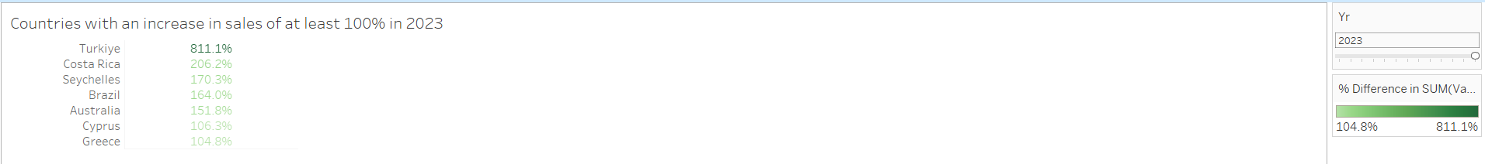

F. Dashboard

We are ready to combine these plots into an interactive dashboard.

- Click on the “New Dashboard” button which is to the right of the “New Worksheet” button at the bottom. This will open a view similar to the following.
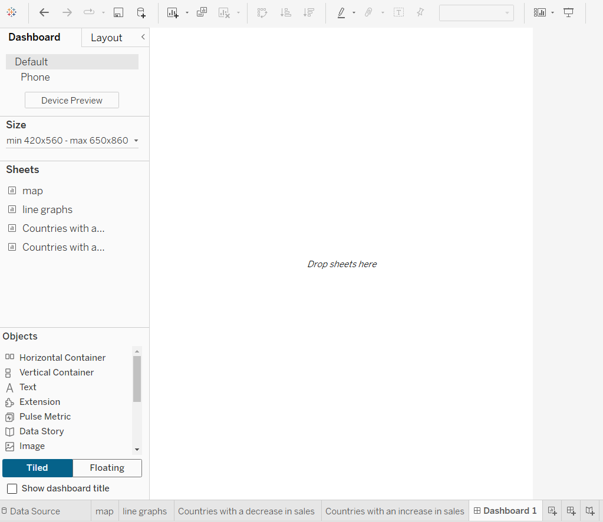
- On the left side under “Size” change the Minimum size to Width=526 px, Height=420 px and Maximum size to Width=1200 px, Height=900 px.

- Drag the “map” and two “Countries…” sheets seen on the left-hand side, onto the white space. Move them so that the map appears at the top and the graph at the bottom. Aim to arrive at the view seen at the end of this section. Note that elements can be deleted by selecting the X symbol at the top right, or set to floating view so that they can be moved to different locations on the dashboard.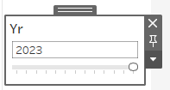

Click here and select “Floating” so that it can be moved to a new location on the dashboard.
- Add text elements for title and instructions by dragging the “Text” object onto the dashboard.
Title: Electric Vehicle sales have increased dramatically worldwide in recent years (size 14)
Another text box says “Hover over a dot to view the country's trend over time” (size 9).

It is good practice to include the data source as part of the visualisation. Here the text contents at the bottom are: “Source: IEA 2024; Global EV Outlook 2024, https://www.iea.org/data-and-statistics/data-product/global-ev-outlook-2024, License: CC BY 4.0.” (size 6 Benton Sans Book font)
- The background colour can be changed by going to Layout, then clicking on the circle to the right of Background 100% - the colour used here is rgb=250,244,231 but you can select a colour of your choice.
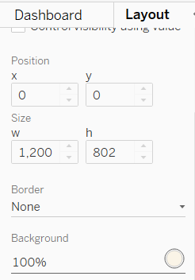

A full-screen view can be seen by selecting the “Presentation mode” icon at the top.

Remember to save your changes at the end!

Bonus exercise: Aim to replicate the bar chart shown below! (Hint: the Year needs to be set to be a discrete parameter so that a bar chart is shown instead of a line chart.)

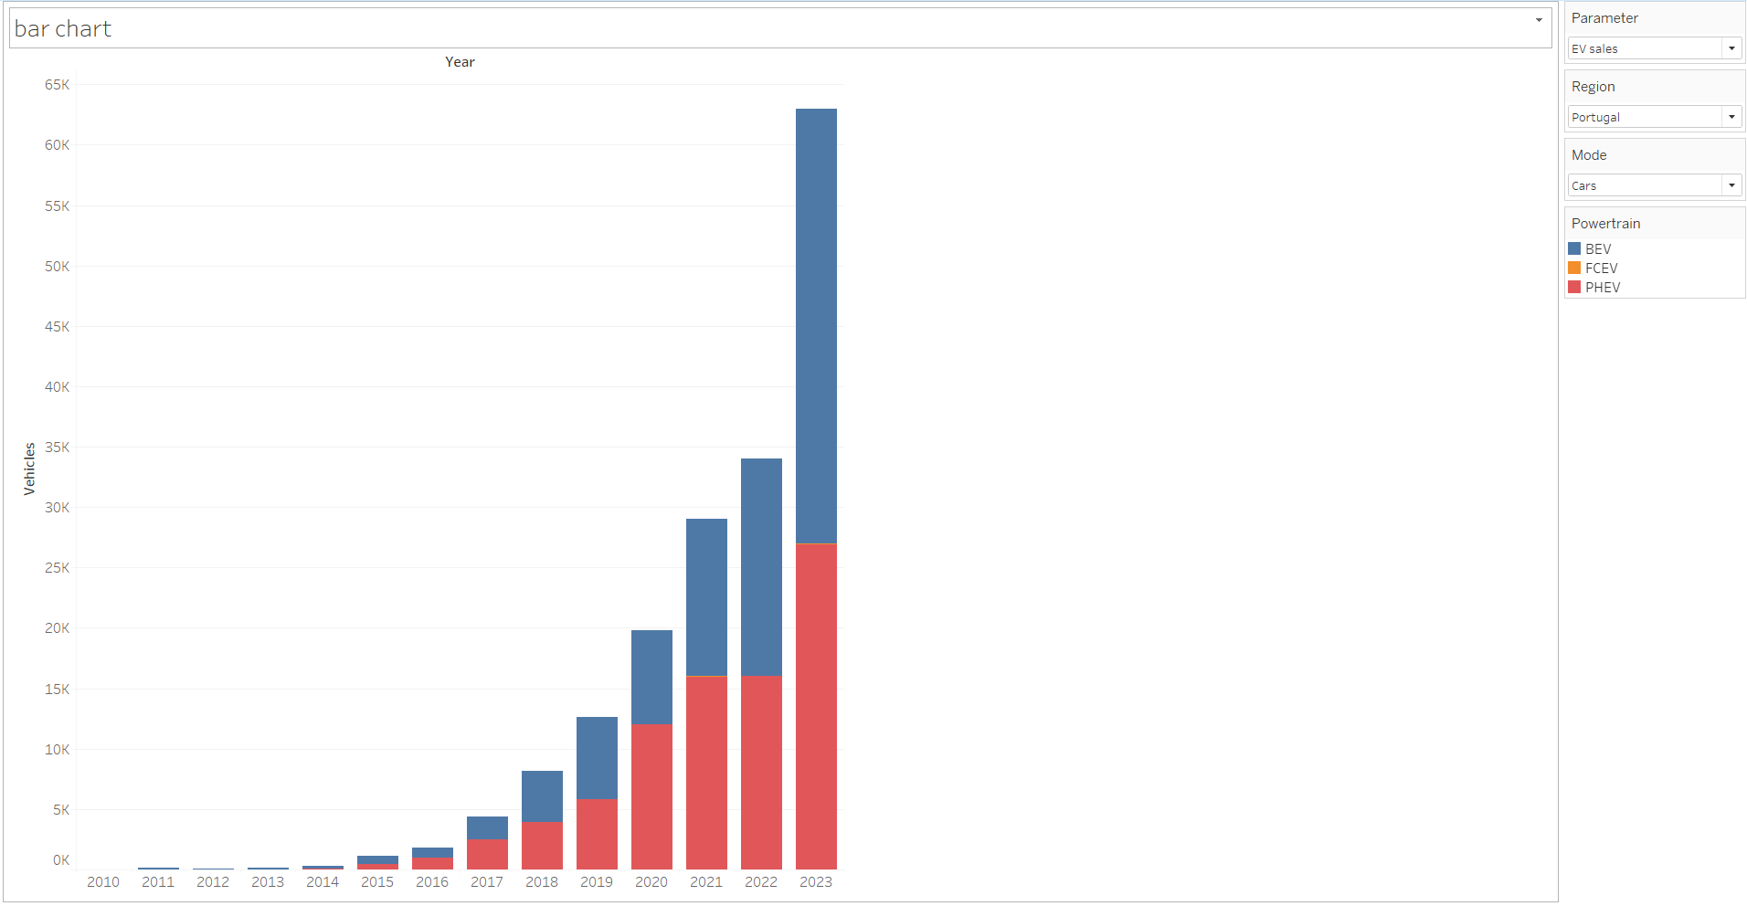

Submission
To submit this lab, you can show it to your Trainer or provide a Tableau Public link.

Summary
The following skills have been learnt after completing this lab.
- Connecting to a data source
- Creating parameters and calculated fields
- Applying filters
- Changing colours
- Creating an interactive map using geospatial information
- Creating a line chart
- Embedding the line chart in the map using the tooltip feature
- Creating a dashboard

References
Viz Gallery
How-To Videos

